**Handson-4**

**Git Bash Commands:**

HP@DESKTOP-RD6TT5J MINGW64 ~

$ cd C:/Users/HP/GitDemo

HP@DESKTOP-RD6TT5J MINGW64 ~/GitDemo (main)

$ git status

On branch main

Your branch is ahead of 'origin/main' by 6 commits.

(use "git push" to publish your local commits)

nothing to commit, working tree clean

HP@DESKTOP-RD6TT5J MINGW64 ~/GitDemo (main)

$ git checkout -b GitWork

Switched to a new branch 'GitWork'

HP@DESKTOP-RD6TT5J MINGW64 ~/GitDemo (GitWork)

$ echo "<greeting>Hello from GitWork branch</greeting>" > hello.xml

HP@DESKTOP-RD6TT5J MINGW64 ~/GitDemo (GitWork)

$ git add hello.xml

warning: in the working copy of 'hello.xml', LF will be replaced by CRLF the next time Git touches it

HP@DESKTOP-RD6TT5J MINGW64 ~/GitDemo (GitWork)

$ git commit -m "Add hello.xml in GitWork branch"

[GitWork f3671cb] Add hello.xml in GitWork branch

1 file changed, 5 deletions(-)

HP@DESKTOP-RD6TT5J MINGW64 ~/GitDemo (GitWork)

$ git remote -v

origin https://github.com/venky212/GitDemo (fetch)

origin https://github.com/venky212/GitDemo (push)

HP@DESKTOP-RD6TT5J MINGW64 ~/GitDemo (GitWork)

$ git checkout -b GitWork

fatal: a branch named 'GitWork' already exists

HP@DESKTOP-RD6TT5J MINGW64 ~/GitDemo (GitWork)

$ git branch -a

* GitWork

NewBranch

main

remotes/origin/NewBranch

remotes/origin/main

HP@DESKTOP-RD6TT5J MINGW64 ~/GitDemo (GitWork)

$ git push -u origin GitWork

Enumerating objects: 18, done.

Counting objects: 100% (18/18), done.

Delta compression using up to 4 threads

Compressing objects: 100% (13/13), done.

Writing objects: 100% (17/17), 1.68 KiB | 287.00 KiB/s, done.

Total 17 (delta 5), reused 0 (delta 0), pack-reused 0 (from 0)

remote: Resolving deltas: 100% (5/5), done.

remote:

remote: Create a pull request for 'GitWork' on GitHub by visiting:

remote: https://github.com/venky212/GitDemo/pull/new/GitWork

remote:

To https://github.com/venky212/GitDemo

* [new branch] GitWork -> GitWork

branch 'GitWork' set up to track 'origin/GitWork'.

HP@DESKTOP-RD6TT5J MINGW64 ~/GitDemo (GitWork)

$ git branch -r

origin/GitWork

origin/NewBranch

origin/main

HP@DESKTOP-RD6TT5J MINGW64 ~/GitDemo (GitWork)

$ echo "<note>Updated in GitWork</note>" >> hello.xml

HP@DESKTOP-RD6TT5J MINGW64 ~/GitDemo (GitWork)

$ git status

On branch GitWork

Your branch is up to date with 'origin/GitWork'.

Changes not staged for commit:

(use "git add <file>..." to update what will be committed)

(use "git restore <file>..." to discard changes in working directory)

modified: hello.xml

no changes added to commit (use "git add" and/or "git commit -a")

HP@DESKTOP-RD6TT5J MINGW64 ~/GitDemo (GitWork)

$ git add hello.xml

warning: in the working copy of 'hello.xml', LF will be replaced by CRLF the next time Git touches it

HP@DESKTOP-RD6TT5J MINGW64 ~/GitDemo (GitWork)

$ git commit -m "Update hello.xml in GitWork branch"

[GitWork 9487504] Update hello.xml in GitWork branch

1 file changed, 1 insertion(+)

HP@DESKTOP-RD6TT5J MINGW64 ~/GitDemo (GitWork)

$ git checkout main

Switched to branch 'main'

Your branch is ahead of 'origin/main' by 6 commits.

(use "git push" to publish your local commits)

HP@DESKTOP-RD6TT5J MINGW64 ~/GitDemo (main)

$ echo "<greeting>Hello from master branch</greeting>" > hello.xml

HP@DESKTOP-RD6TT5J MINGW64 ~/GitDemo (main)

$ git add hello.xml

warning: in the working copy of 'hello.xml', LF will be replaced by CRLF the next time Git touches it

HP@DESKTOP-RD6TT5J MINGW64 ~/GitDemo (main)

$ git commit -m "Add hello.xml in master branch with different content"

[main e567443] Add hello.xml in master branch with different content

1 file changed, 1 insertion(+), 6 deletions(-)

HP@DESKTOP-RD6TT5J MINGW64 ~/GitDemo (main)

$ git log --oneline --graph --decorate --all

* e567443 (**HEAD** -> **main**) Add hello.xml in master branch with different content

| * 9487504 (**GitWork**) Update hello.xml in GitWork branch

| * f3671cb (**origin/GitWork**) Add hello.xml in GitWork branch

|/

* 6bab8cf Resolve merge conflict in hello.xml (choose merged content)

|\

| * 4dd6319 Update hello.xml in GitWork branch

| * bcd79b7 Add hello.xml on GitWork branch

* | dc10a4e Add hello.xml on main with different content

|/

* 494cfa2 Add files to GitNewBranch

| * fe52fff (**origin/NewBranch**, **NewBranch**) Add files to GitNewBranch

|/

* aaf9d44 Ignore .log files and log directory

* 2c49024 (**origin/main**) Add .gitignore to ignore .log files and log/ folder

* 3ccdf6c Add .gitignore to ignore .log files and log/ folder

* 2032de0 Add welcome.txt

HP@DESKTOP-RD6TT5J MINGW64 ~/GitDemo (main)

$ git diff main..GitWork

**diff --git a/hello.xml b/hello.xml**

**index 2d8d754..b8772c1 100644**

**--- a/hello.xml**

**+++ b/hello.xml**

@@ -1 +1,2 @@

-<greeting>Hello from master branch</greeting>

+<greeting>Hello from GitWork branch</greeting>

+<note>Updated in GitWork</note>

HP@DESKTOP-RD6TT5J MINGW64 ~/GitDemo (main)

$ git checkout main

Already on 'main'

Your branch is ahead of 'origin/main' by 7 commits.

(use "git push" to publish your local commits)

HP@DESKTOP-RD6TT5J MINGW64 ~/GitDemo (main)

$ git merge GitWork

Auto-merging hello.xml

CONFLICT (content): Merge conflict in hello.xml

Automatic merge failed; fix conflicts and then commit the result.

HP@DESKTOP-RD6TT5J MINGW64 ~/GitDemo (main|MERGING)

$ git add hello.xml

HP@DESKTOP-RD6TT5J MINGW64 ~/GitDemo (main|MERGING)

$ git commit -m "Resolve merge conflict in hello.xml"

[main 8cb0c1f] Resolve merge conflict in hello.xml

HP@DESKTOP-RD6TT5J MINGW64 ~/GitDemo (main)

$ git status

On branch main

Your branch is ahead of 'origin/main' by 10 commits.

(use "git push" to publish your local commits)

nothing to commit, working tree clean

HP@DESKTOP-RD6TT5J MINGW64 ~/GitDemo (main)

$ echo "*.orig" >> .gitignore

HP@DESKTOP-RD6TT5J MINGW64 ~/GitDemo (main)

$ git add .gitignore

warning: in the working copy of '.gitignore', LF will be replaced by CRLF the next time Git touches it

HP@DESKTOP-RD6TT5J MINGW64 ~/GitDemo (main)

$ git commit -m "Ignore merge backup files"

[main 01b8ffa] Ignore merge backup files

1 file changed, 1 insertion(+)

HP@DESKTOP-RD6TT5J MINGW64 ~/GitDemo (main)

$ git branch -a

GitWork

NewBranch

* main

remotes/origin/GitWork

remotes/origin/NewBranch

remotes/origin/main

HP@DESKTOP-RD6TT5J MINGW64 ~/GitDemo (main)

$ git push -u origin GitWork

Enumerating objects: 5, done.

Counting objects: 100% (5/5), done.

Delta compression using up to 4 threads

Compressing objects: 100% (3/3), done.

Writing objects: 100% (3/3), 341 bytes | 341.00 KiB/s, done.

Total 3 (delta 1), reused 0 (delta 0), pack-reused 0 (from 0)

remote: Resolving deltas: 100% (1/1), completed with 1 local object.

To https://github.com/venky212/GitDemo

f3671cb..9487504 GitWork -> GitWork

branch 'GitWork' set up to track 'origin/GitWork'.

HP@DESKTOP-RD6TT5J MINGW64 ~/GitDemo (main)

$ git branch -d GitWork

Deleted branch GitWork (was 9487504).

HP@DESKTOP-RD6TT5J MINGW64 ~/GitDemo (main)

$ git push origin --delete GitWork

To https://github.com/venky212/GitDemo

- [deleted] GitWork

HP@DESKTOP-RD6TT5J MINGW64 ~/GitDemo (main)

$

**Output :  
GitWork branch Created:**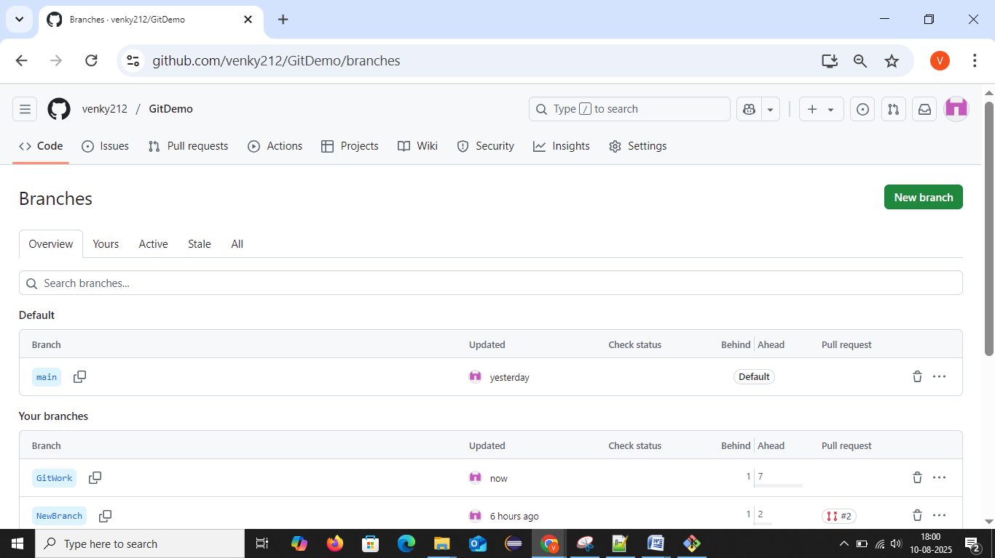

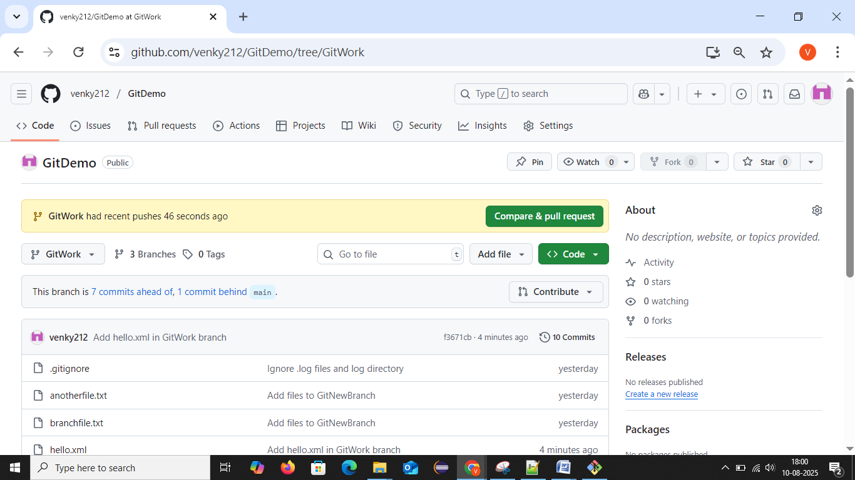

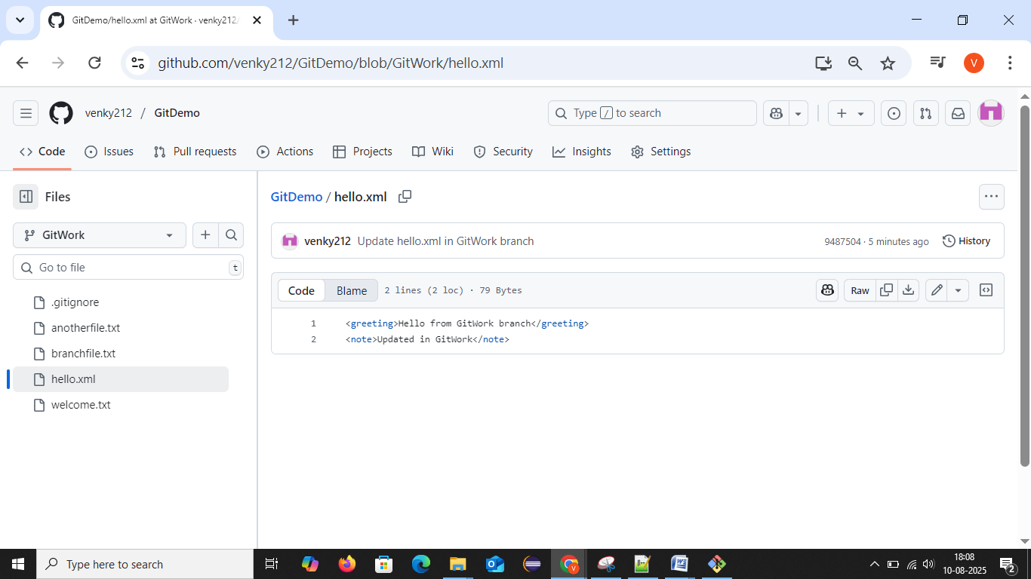

**Branch Deleted:**

